Week 6 Book Suggestions - Dragon Tales

Anderson County Library Summer Reading Program 2021

The 2021 theme is “Tails & Tales.”

* + - * *Dragon’s fat cat* by Dav Pilkey
      * *Dragonbreath* by Ursula Vernon
      * *D is for dragon* dance by Ying Chang Compestine
      * *You don’t want a dragon* by Amy Dyckman
      * *Sir Pete the Brave* by James Dean
      * *Saint George and the dragon* by Margaret Hodges
      * *Dragons love tacos* by Adam Rubin
      * *The library dragon* by Carmen Agra Deedy
      * *Attack of the Underwear Dragon*

*These are stories your child may like, however, they are not required reading.*

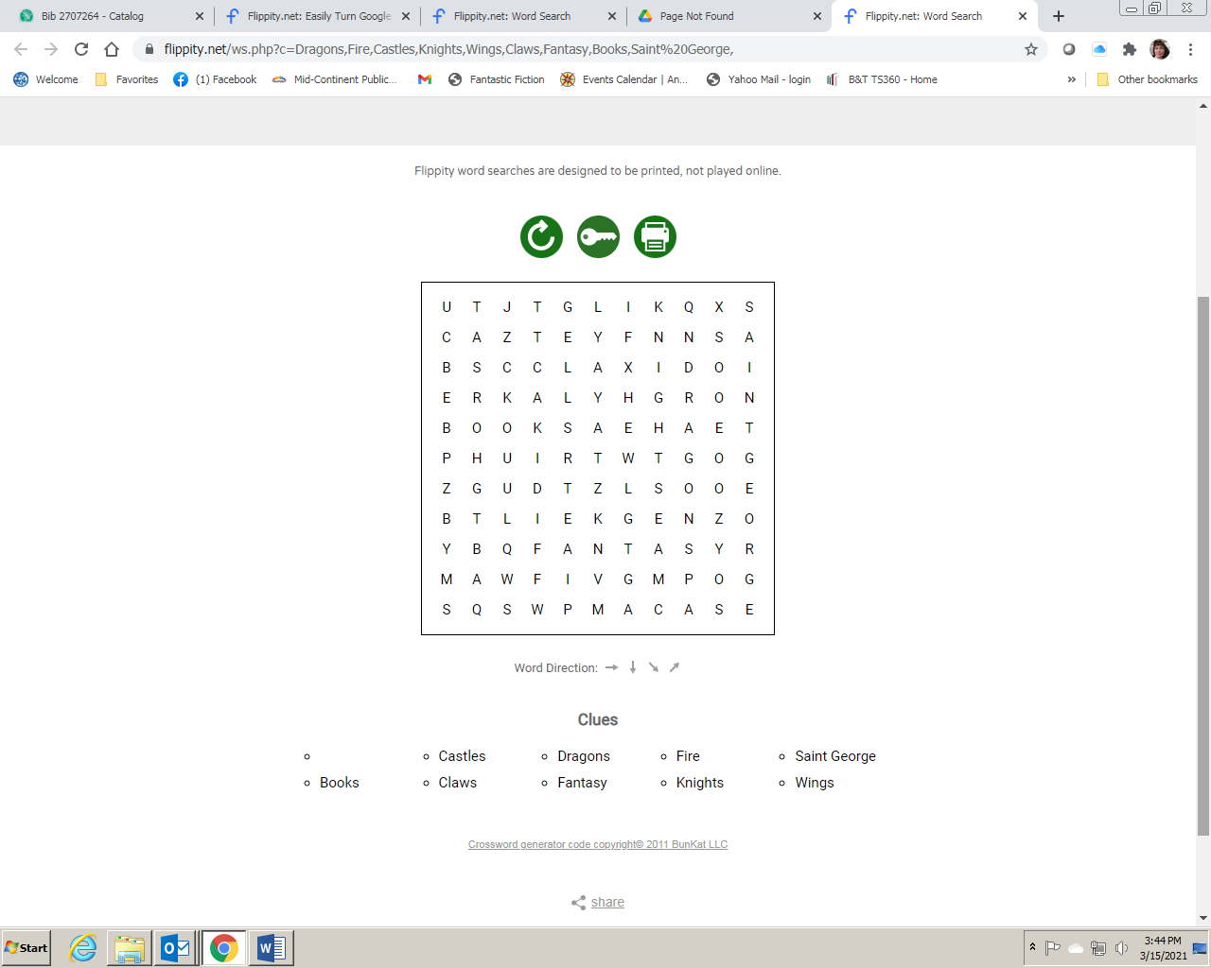

Clues

Claws Saint George

Castles Knights

Books Dragons

Fantasy Fire Wings



**Add some movement to your day with this Dragon Dance video!** [**https://www.youtube.com/watch?v=iCgQWb3qg98**](https://www.youtube.com/watch?v=iCgQWb3qg98)

Answer Key