Week 3 Book Suggestions - Folk tales
Anderson County Library Summer Reading Program 2021
The 2021 theme is “Tails & Tales.”

- Puss in boots by Charles Perrault
- Lion and Mouse by Jerry Pinkney
- Grasshopper and Ant by Jerry Pinkney
- Bruh Rabbit and the tar baby girl by Virginia Hamilton
- Tikki Tikki Tembo by Arlene Mosel
- Zomo the rabbit by Gerald McDermott
- Any Peter Cottontail story by Beatrix Potter
- The runaway bunny by Margaret Wise Brown
- Lucy LongWhiskers by Daisy Meadows

These are stories your child may like, however, they are not required reading.

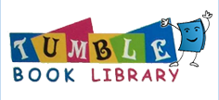

Put this week’s e-resources here. Then only print out 1 piece of paper

