The Yeti! Instructions

Fold along all dotted lines with pictures facing out.

Glue boxes together.

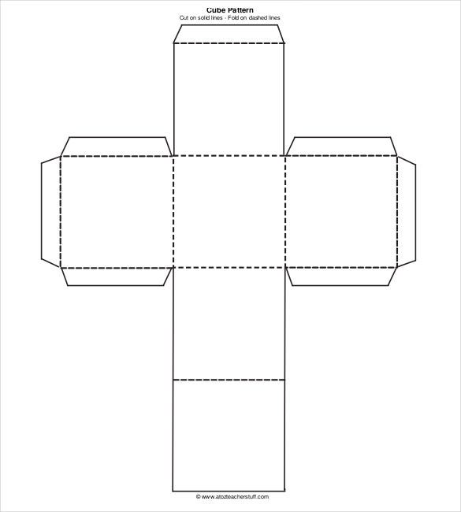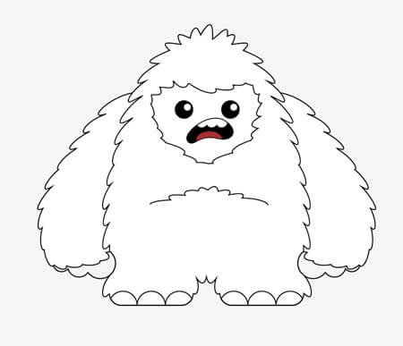

Glue

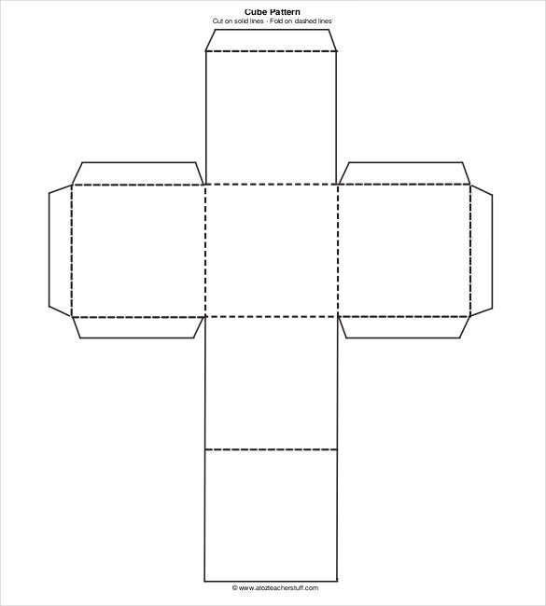

Glue

