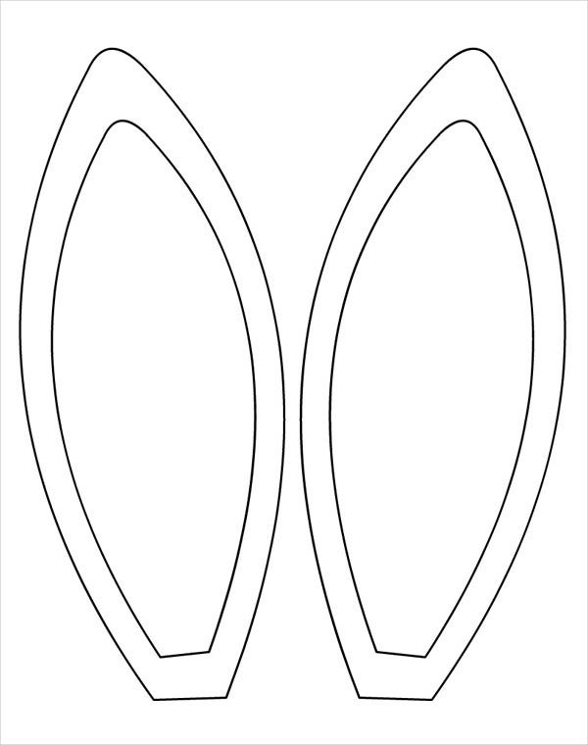

Color the inside of the ears pink

Cut out ears

Tape to Headband (sides of this paper)

Read a book about bunnies to your child