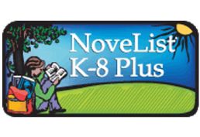

NoveList K-8 Plus: The app that helps you find great books for your kid!

This week’s electronic activity is brought to you by the Anderson County Library!

Go to www.andersonlibrary.org . Select Services. Select For Children. Scroll down and select Kids’ Databases. Select NoveList K-8 Plus.

Select your child’s age and the kind of books they’d like to read. You can also enter a book your child already likes and find “Read-Alikes”. If the Anderson County Library does not have the book you want, you can request it be purchased, place it on hold from the Consortium, or obtain it through ILL.

Congratulations! You have just completed this week’s activity!