E-Resources Week 3
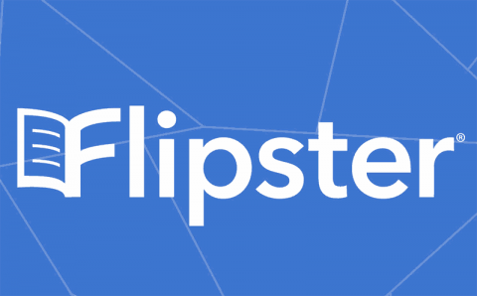
Have you heard about the Flipster app?
Download it today and borrow interesting, educational magazines for you or your child! (You’ll need your library card number.) Ask magazine is a good one, as well as National Geographic Kids! There are never any late fees when you borrow a digital magazine.
Congratulations! You have just completed the activity for Week 3. If your child reads a magazine article, be sure to log that on their reading log.

