Name:______________________

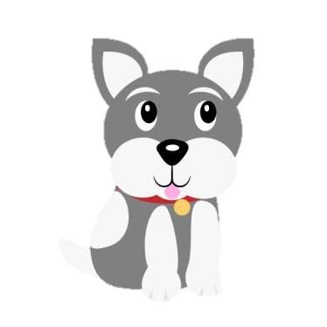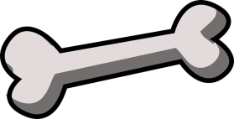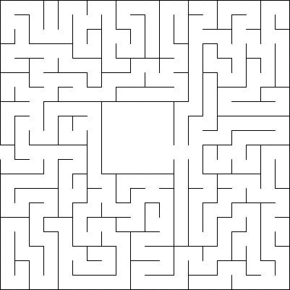**Help the puppy find his bone.**