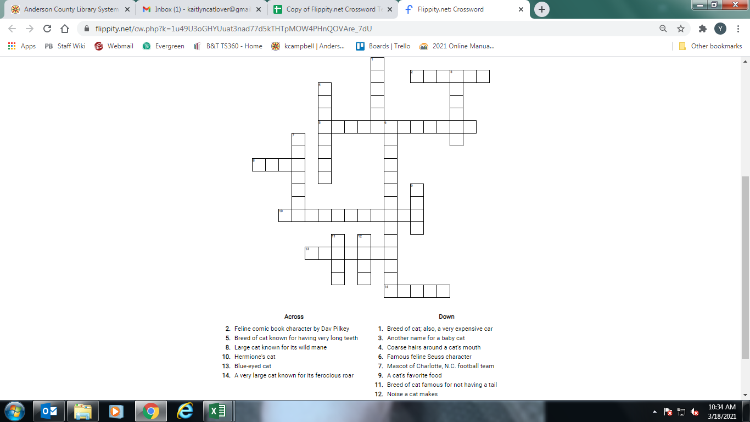

1. Jaguar 2. Catkid 3. Kitten 4. Whiskers 5. Sabertoothed 6. The Cat in the Hat 7. Panther

8. Lion 9. Fish 10. Crookshanks 11. Manx 12. Meow 13. Siamese 14. Tiger