Week 2 Book Suggestions - Dinosaurs!
Anderson County Library Summer Reading Program 2021
The 2021 theme is “Tails & Tales.”

- How do dinosaurs show good manners? By Jane Yolen
- Dinosaur kisses by David Ezra Stein
- What the dinosaurs did last night by Tuma Refe
- Dinosaurs before dark by Mary Pope Osborne
- Dinosaurs discovered by Dean Lomax
- My amazing dinosaur : Tib & Tumtum by Grimaldi

These are stories your child may like, however, they are not required reading.

Add some movement to your summer! Take a look at this fun dinosaur dance video for children and families:
https://www.youtube.com/watch?v=6dqx088Eif0

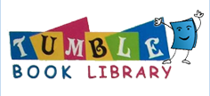

Insert this week’s e-resources here and use only one piece of paper to print this one.

