How to Make a Draped Hypertufa Planter

Check out her site and YouTube channel!

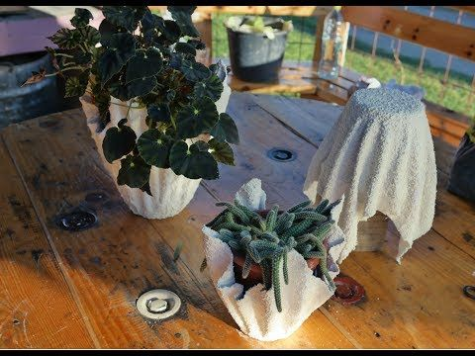

Website: https://www.thehypertufagardener.com/revisit-draped-hypertufa-planter/

YouTube Channel: https://www.youtube.com/watch?v=h9Em0DcGBGc

Recipe
- 1 part Portland cement
- 1/4 part of peat
- a handful of vermiculite depending on how much you want it to be textured (I didn’t use the mortar)
- Put on your mask! The cement is very dusty and will get all in the air, if possible do the project outside, OR at least mix it outside.

- add water slowly until it begins to look like a thick pancake mix. You should be able to mix the cloth so that it gets a nice thick coat clinging to it.
Hey Everyone! I portioned the quantities out so basically use it all! Make sure you slowly add the water in until you have the consistency you want.
Second Point! If you are doing this project with two youth, you can cut the towel in half so each can create their own!

Instructions:
Cut the fabric into a circle, an oval, or even use it as a rectangle or square. Dampen it and hang it from your “tower.” This will be the support that you hang it on to dry. If you want the pointed edges, be sure your support is tall enough to allow them to drape/hang.
Your tower is your support for the project as it dries. It must be something sturdy to allow your fabric to “drape” and not let the ends of the wet fabric touch to floor. It will change the look of your project if the ends of the fabric touch the floor/table. Cover your tower in plastic! You don’t want your piece to cement itself to the tower.
Check out how it hangs/ “drapes” and pull it to one side or the other until you have a vision of what you like. Wearing gloves, put the whole piece of cloth into your mix and roll it around until it is all soaked with cement on both sides. Be sure to mix up enough slurry to get it all wet, be ready because your cloth will be heavy when it is soaked! When you are draping it over your tower, it is easy to pull and adjust until you get the look that pleases you.
Final Note: the hypertufa pots are not to be used as planters (i.e. putting soil in them and the plant.) The plant that you put in your pot should already be in a pot and have a plastic water catcher underneath it.

