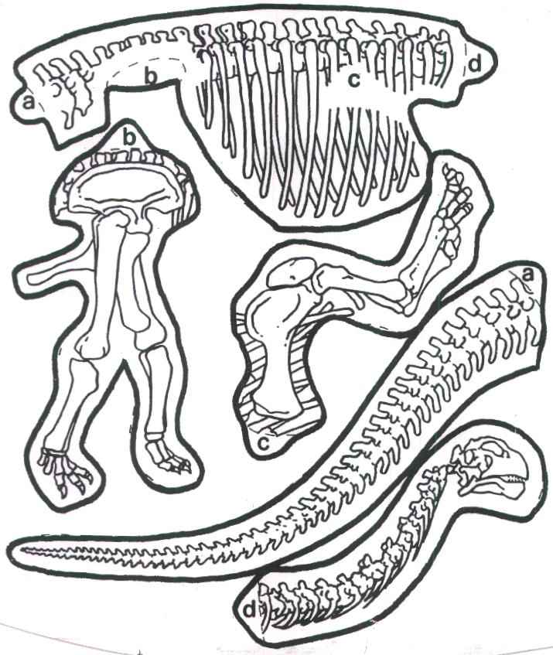

**Dino skeleton**

Cut out body parts. Match the letters on the body to the letters on the limbs. Glue in place.