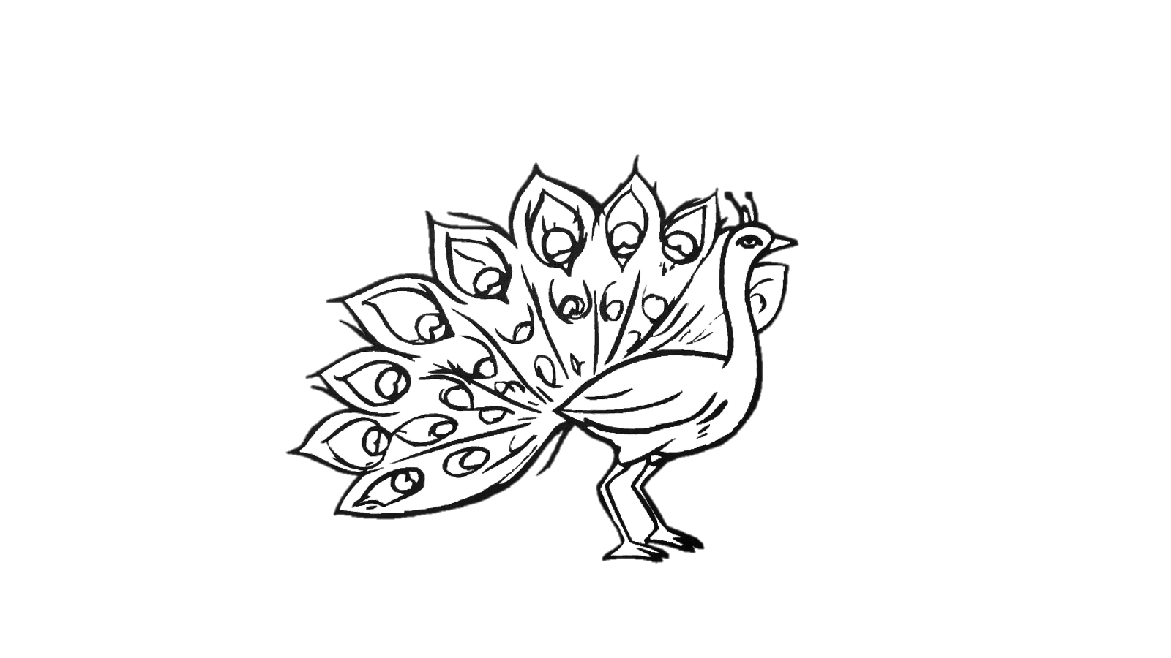Name__________________________