Veggie Friendly Turkey Snack
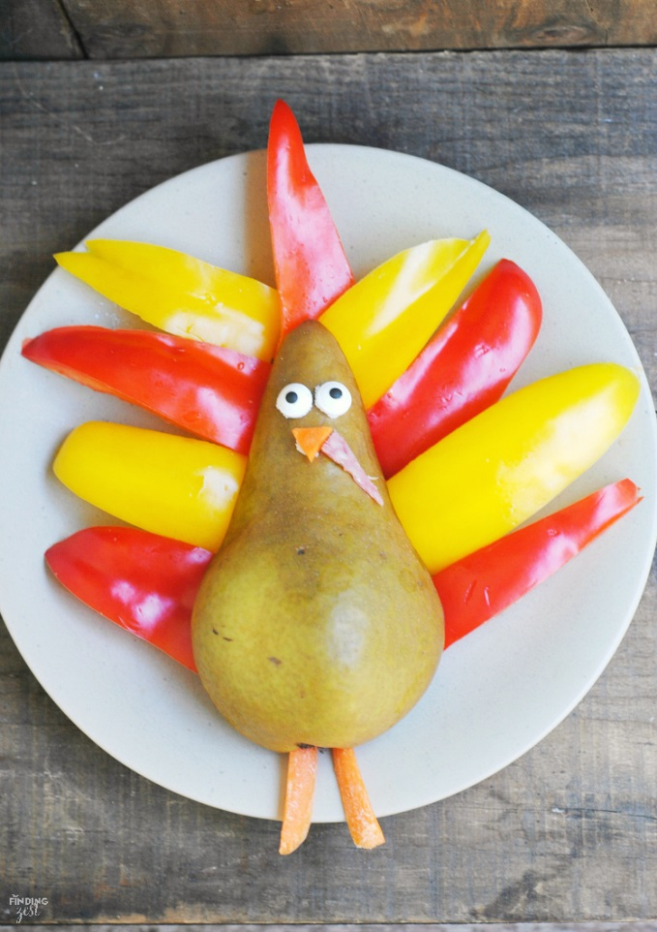
https://www.findingzest.com/fruit-and-veggie-turkey-kid-friendly-thanksgiving-snack/

Ingredients
- 1 Bosc or Barlett pear, cut in half
- 1 baby carrot (nose and feet)
- 1 yellow pepper, seeded and cut into slices
- 1 red pepper, seeded and cut into slices
- 2 Wilton candy eyes
- white frosting or peanut butter
- 1 piece of salami, ham or pepperoni (tiny gizzard piece)
Instructions
- Lay the pear cut side down on a medium size plate.
- Add a tiny bit of white frosting to the back of the candy googly eyes using a toothpick to give your turkey some eyes.
- Slice your baby carrot and cut a small triangle from one of the pieces to use as his nose.
- Apply some frosting or peanut butter to the back to adhere it to the pear.
- Use another 2 slices of carrot for his legs.
- Finally cut a tiny longer triangle out of the salami/ham/pepperoni for his gizzard.
- Arrange his 'feathers' by lining them around the pear.
Wordpress Recipe Plugin by EasyRecipe

