Fun with Beaks

Objectives: To do an elementary study of ornithology (birds), specifically studying beaks.

Materials: 1 spoon
1 cup or bowl
1 set of chopsticks
1 craft stick
1 clothespin
10 pieces of macaroni
10 dry beans
10 cotton balls or small pom poms
10 pieces of yarn

Introduction: Did you know that a bird’s beak consists of a skeletal structure in their skull that is wrapped in keratin (a substance found in hair and fingernails.) Birds’ beaks function like tools and fulfill many purposes. They help birds collect food and construct nests. They also help them clean their feathers and protect/defend themselves. The shape of beaks varies. It provides information and determines what foods they can and will eat.
Specific birds such as raptors (including owls, hawks and vultures) have beaks that are very helpful with holding things. Their beaks look like a hook, which allows birds to pull apart what they plan to eat. Beaks also help them break apart seeds when they eat them. Spoonbills are a type of bird in which their beaks are long and flat for scooping up their food from water, such as fish.

Procedure:
1. Study the different beaks (spoon, clothespin, craft stick, chopsticks) and guess which food (yarn, pom pom, beans, macaroni) you will be able to pick up. Which foods do you think each beak will pick up the easiest?

2. Spread the “food” out in front of you.

3. Select a “beak” and use a cup or bowl as the stomach of the bird. See how many pieces of “food” you can pick up in 30 seconds and put them in the stomach of the bird. Make sure only one piece of food is picked up at a time.

4. Count how many pieces your beak picks up in 30 seconds and record your findings.

5. Spread all the “food” back out and complete again using a different type of beak.

Discuss:
1. Which beak was able to pick up the most food?
2. What other types of food can be eaten or picked up with your beaks?

Extra: Next time when you go on a trip or vacation take a nature walk and see how many different kinds of birds you discover and notice the different beaks they have.

Review: Which beak goes best with which type of food?

Fernbank Science Center in Atlanta has a good resource for studying beaks and bills. Includes an activity for children to match a bird’s beak to the types of food it eats. You can find it here: http://www.fernbank.edu/Birding/bird_beaks.htm

Which birds have a grasping beak? Which birds have a cooping beak?
A shovel beak? A probing beak?

Take a nature walk together as a family and look for birds. Can you identify the birds or their beaks?

Book picks:

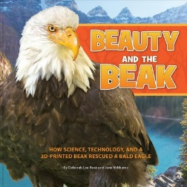
- Beauty and the beak: How science, technology, and a 3D-printed beak rescued a bald eagle by Deborah Lee Rose and Jane Veltkamp.
If you don’t do anything else in your study of ornithology, read this book. It’s about a female eagle whose beak was badly damaged by a bullet. A policeman found the injured bird and brought her to scientists that could help her. They named her Beauty. Some of the photographs are absolutely stunning, in-flight shots of these birds that give the reader a sense of awe at the daily lives of these majestic creatures. This is the encouraging story of an injured bird, and the team of humans who helped her. The authors’ notes at the end give more interesting facts about bald eagles and their environment.

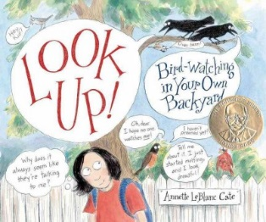
Look up! Bird-watching in your own back yard by Annette LeBlanc Cate.

- This book is illustrated in a kid-friendly format and includes a bibliography at the end for more resources. The author encourages kids and families to get outside and begin watching birds. There are pointers on how to get started, a section on what to look for during migration, and much more. Some of the drawings may not be as accurate as photographs, but this book is a good place to start when birdwatching with children.

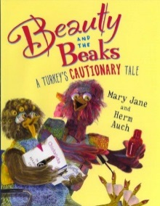
Beauty and the beaks: A turkey’s cautionary tale by Mary Jane and Herm Auch

- This hilarious picture book is definitely not scientific, but it’s a lot of fun! A hen named Beauty owns a salon called The Chic Hen, which is the center of gossip. She likes to “eggsercise” and go “eggsploring”. One day, a turkey named Lance walks in, and through a series of mishaps and misunderstandings, realizes he’s meant to be the Thanksgiving dinner. Beauty and her friends work together to mastermind a disguise, and the farmer and his wife have to make alternate plans for their Thanksgiving dinner. Supplement your study of birds with a light, funny story, and try to guess what things turkeys eat based on the shape of their beaks.

