Scarecrow Runway Contest Instructions
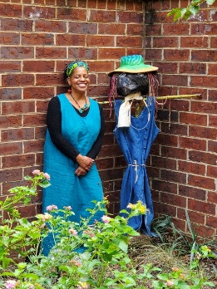

Greetings Everyone!
Welcome to the Scarecrow Runway Contest! Me and Ms. Helen (we took the above picture in the garden as we talked about this contest, she is so happy you all want to build a scarecrow!) We know everyone is going to do a phenomenal job, so we wanted to just give you a few pointers before you get started:
- The contest begins October 1st and ends October 22nd.
- The scarecrows will be judged on the following:
- creativity (types of materials used, design of scarecrow)…
- cultural relevants (history of your scarecrow why did your community use scarecrows,)
- visual distinction (does it have a distinct look that yields personality? Reference the web link for more information: https://www.google.com/url?sa=t&source=web&rct=j&url=https://historybecauseitshere.weebly.com/scarecrows-historically-speaking.html&ved=2ahUKEwjS1om5w4zsAhVRmVkKHUJ5CyEQFjAMegQIARAB&usg=AOvVaw16k1yhZkHVHG2b3LZN21H-
- All submissions must be in by close of business October 22nd.
- Video Submission Process:
- Video tape the scarecrow from every side (front, back, left side and right side)
- Make sure the camera is close enough for the judges to see the detail.
- Explain how you made your scarecrow and any key points that will show how you implemented the three judging criteria.
- Make sure you keep the camera on each side long enough for the judges to really see your creativity and ingenuity!
- Explain how your scarecrow meets each of the criteria.
- Submit! (Send your submission to google drive and share with ahuvyahandersonlibrary@gmail.com

- The Scarecrows will be judged between October 26th through the 28th and the winner will be notified by October 29th.
- If you have any questions let us know! amoorhead@andersonlibrary.org
- Also go to our website and check out the cool PDF Ms. Dodie created giving you lots of information on building a Scarecrow.
See you all soon! Make sure you stop through and say high to me and Ms. Helen!

