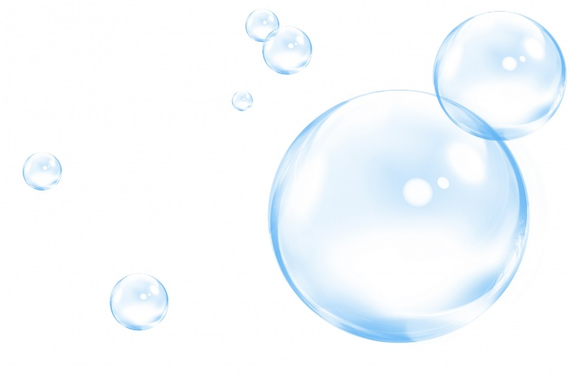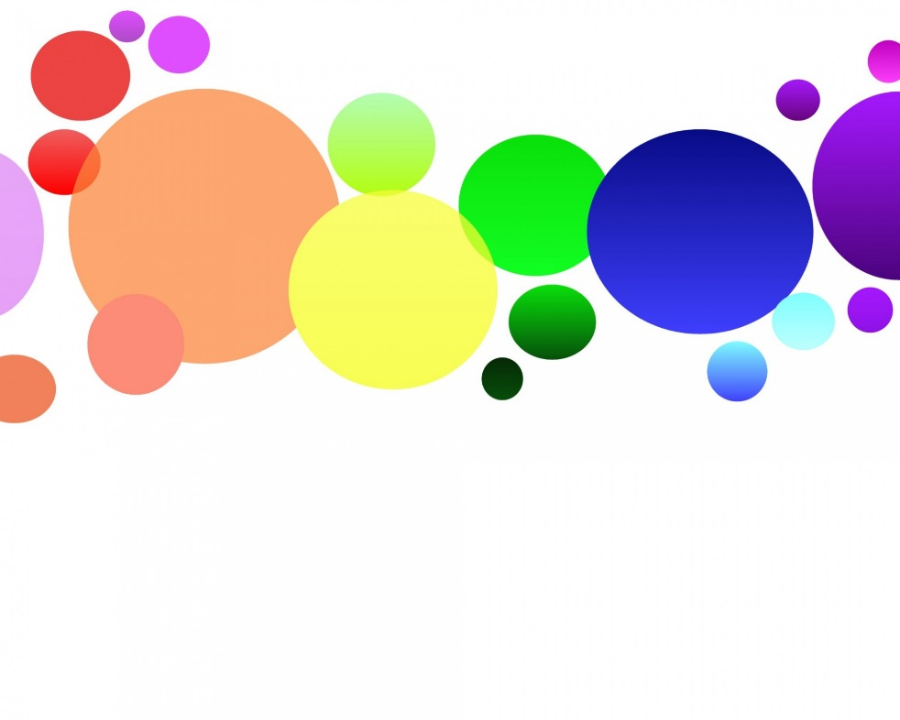

The DIY Lava Lamp

You will need

1 glass container

Water

Vegetable oil

Food coloring

Effervescent tablets

